MidTerm

PROJECT I

- On the File menu, point to New, and then click Project.
- In the New Project dialog box, choose Windows Application.
- Name the application ProjectI_FirstName_LastName.
- Rename the default form to frmMain.
- Set the WindowState property to Maximized.
- Set the FormBorderStyle property to None.
- Arrange the controls and change their text properties as shown in Figure 1.
- Write the required code for loading the following forms (which you will create in your MidTerm project):
frmConnection
frmCommand
frmBindingSources
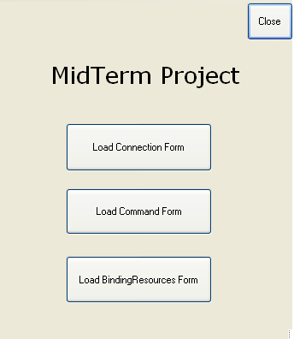

Figure 1 – Main Form

- Database Programming

- Add a new form to your project. Rename it to frmConnection.
- In Solution Explorer, right-click your project and select Add→ New Item. Add an Application Configuration File from the Add New Item dialog box to your project.
- In Solution Explorer, Select the App.config file and add the following tags after the <Configuration> tag:

<connectionStrings>
<add name="J2EENorthwind"
connectionString="Data Source=WWW.J2EE.CA;database=northwind;
Trusted_Connection=No;uid=aspx;password=aspx;"
providerName="System.Data.SqlClient" />
</connectionStrings>

- Select frmConnection and switch to code view. Add the following using directives:
using System.Confiuration;
using System.Data.SqlClient;
- Place a Button control (btnConnectionInfo) on the frmConnection. In the click event handler of btnConnectionInfo, retrieve the Connection String from the App.config file and store it to a variable called connStr.
Create the connection object and open it as shown here:
sqlConnection conn = new sqlConnection(connStr);
conn.Open();

- Use the conn object, retrieve the following information from J2EE SQL Server and show the results on your form:
  - Connection Timeout
  - Packet Size
  - ServerVersion
  - State
  - Workstation ID
- Add a new form to your project. Rename it to frmCommand.
- Add a TextBox control (txtQuery), a Button control (btnExecute), and a DataGridView control (dgvResults) to the form. Set the Multiline property of the TextBox control to true.
- Switch to the code view and add the following using directives:
using System.Confiuration;
using System.Data.SqlClient;
- Double-click the Button control and write the required code to execute the query when the Execute Query button is clicked:
  - Create a SqlConnection object (conn) to represent the connection to Northwind database
// TODO
  - Create a sqlCommand object (cmd) to represent the query
SqlCommand cmd = conn.CreateCommand();
cmd.CommandType = CommandType.Text;
cmd.CommandText = txtQuery.Text;
  - Create a sqlDataAdapter object (da) to talk to the database
// TODO
  - Create a DataSet (ds) to hold the results
// TODO
  - Fill the DataSet: Da.Fill(ds, “Results”);
  - Bind the DataSet to the DataGridView
dgvResults.DataSource = ds;
dgvResults.DataMember = “Results”;

  - Enter the following queries in the Query text box and click on the
Execute Query button:

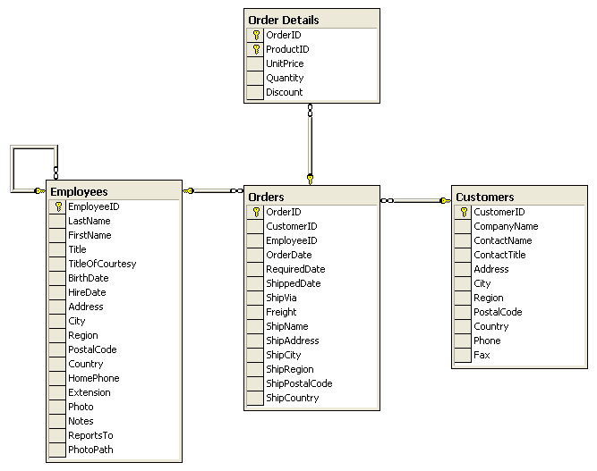

    - SELECT * FROM EMPLOYEES
    - SELECT * FROM CUSTOMERS
WHERE CustomerID LIKE ‘BLON[D-P]’
    - SELECT OrderID, Customers.CustomerID
FROM ORDERS INNER JOIN CUSTOMERS
ON Orders.CustomerID = Customers.CustomerID
    - SELECT OrderID, Customers.CustomerID, Employees.EmployeeID
FROM EMPLOYEES INNER JOIN
(CUSTOMERS INNER JOIN ORDERS
ON CUSTOMERS.CustomerID = Orders.CustomerID)
ON Employees.EmployeeID = Orders.EmployeeID
    - SELECT * FROM CUSTOMERS
ORDER BY Country ASC, PostalCode DESC
    - SELECT Count(CustomerID) AS CustCount, Country
FROM Customers
GROUP BY Country
    - SELECT ProductID, Sum(Quantity) AS TotalSales
FROM [ORDER DETAILS]
WHERE Quantity > 10
GROUP BY ProductID
HAVING Sum (Quantity) > 1000
ORDER BY Sum (Quantity) DESC
- Add a new form to your project. Rename it to frmBindingSources.
- Add four Textbox controls (txtEmployeeID, txtHireDate, txtFullName, txtPosition), five Button controls (btnCreateEmployees, btnNext, btnPrevious, btnLast, btnFirst), and one pictureBox control (picEmployees) to the form. Arrange the controls and change their text properties as shown in Figure 2.

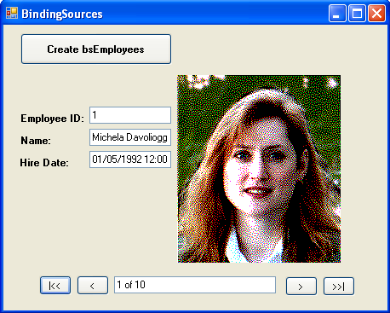

Figure 2 – BindingSources From

Tip: Data Access Layer (DAL)
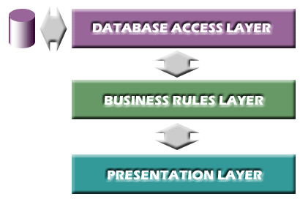
This layer is where you will write some generic methods to interface with your data. In general, this Data Layer, obviously, contains no data, no business rules or data manipulation or transformation logic. It is merely a reusable interface to the database.
Example 1) you can write a method for creating and opening a Connection object, and another for creating and using a Command object, etc.
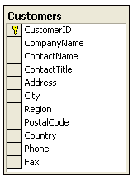
Example 2) you can create your Data Access Layer (DAL) for Customers table by following the below steps suggested by Table Data Gateway (TDG) pattern.
Step One) Add a class to the project and call it Customers.cs.
Create a class called customer to hold information about the customer.
public class Customer
{
private string _companyname, _contactname, _contacttitle, _id;
private string _street, _postalcode, _city, _country, _phone, _region, _fax;

public Customer()
{
}

// PROPERTIES

// CompanyName
public string CompanyName
{
get { return _companyname; }
set { _companyname = value; }
}

// ContactName
public string ContactName
{
get { return _contactname; }
set { _contactname = value; }
}

And so on…
}

Step Two) Create a class called CustomerCollection which is the collection of customer objects.
public class CustomerCollection : List<Customer>
{
}
Step Three) Create a class called customers which is the behavior of the customer.
public class Customers
{
public static string ConnectionString
{
get { return ConfigurationManager.ConnectionStrings["LocalNWind"].ConnectionString; }
}

// METHODS

// Load
public static Customer Load(string id)
// Load
public static CustomerCollection LoadSet(string match)

// LoadAll
public static CustomerCollection LoadAll()
public static CustomerCollection LoadAll(int totalRows, int firstRow)
public static CustomerCollection LoadAll(int totalRows, int firstRow, string sortExpression)

// LoadByCountry
public static CustomerCollection LoadByCountry(string country)
public static CustomerCollection LoadByCountry(string country, int totalRows, int firstRow)
public static CustomerCollection LoadByCountry(string country, int totalRows, int firstRow, string sortExpression)

// GetCustomerCountries
public static StringCollection GetCustomerCountries()
// Save
public static void Save(Customer cust)
// Add
public static void Add(Customer cust)
// Delete
public static void Delete(string id)
public static void Delete(Customer cust)

}

Step Four) Create a partial class called HelperMethods for the preceding methods.
public static partial class HelperMethods
{
// GetCustomer
public static Customer GetCustomer(SqlDataReader reader)

// FillCustomerList
public static void FillCustomerList(CustomerCollection coll, SqlDataReader reader)
public static void FillCustomerList(CustomerCollection coll, SqlDataReader reader, int totalRows, int firstRow)
}
Step Five) Add another class to project and call it CustomersManager.cs.
Create a class called CustomersManager which allows you to manage some specific methods, such as GetListofCustomers(), GetCustomerDetails(), and so on.

- Notice - Study the Customers.cs, EmployeesManager.cs files located in ftp://share.bcit.ca/out/comp/2691/MidTerm/ and then create a new DAL for Employees table.
Customers.cs, EmployeesManager.cs files just provide you the best approach for designing the enterprise level applications. For this project, you need to implement some functions that you will need them in the next steps.
- In Solution Explorer, right-click your project and select Add→ New Folder. Name it App_Code. Add Employees.cs and EmployeesManager.cs to this folder.

- Select frmBindingSources and switch to code view. Add the following code before the BindingSources constructor.
BindingSource bsEmployees;

- Select frmBindingSources and switch to designer view. Double click the btnCreateEmployee and add the following code in the click event handler:
bsEmployees = new BindingSource();
EmployeesManager EmployeesManager1 = new EmployeesManager();
bsEmployees.DataSource = EmployeesManager1.GetListofEmployees();
tbEmployeeID.DataBindings.Add("Text", bsEmployees, "EmployeeID");
// TODO
tbHireDate
tbFullName
picEmployees
bsEmployees.PositionChanged += new EventHandler(bsEmployees_PositionChanged);

- Create a new event called bsEmployees_PositionChanged and add the following code in its event handler:
txtPosition.Text = (bsEmployees.Position + 1).ToString() + " of "
+ bsEmployees.Count.ToString();

- Double click on the btnFirst, btnLast, btnNext, btnPrevious and write the required code.

Case Scenarios

Case Scenario 1: Designing an Application

You have recently accepted a job as an internal application developer in the information technology department of an enterprise healthcare company. Your first task is to design an internal application that employees will use to manage information about customers (whom everyone calls “subscribers”), their current plans, medications, and chosen doctors.
Answer the following questions about your design choices:
1. We need to manage information about both subscribers and doctors. How will you do this? Will you have one class for both, two separate classes, or what?
2. Our employees need to search for groups of subscribers or doctors. For example, if a doctor retires, we need to contact all that doctor’s subscribers and assist them in finding a new physician. Similarly, we contact doctors annually to renew their contracts. How can you store a group of subscribers or doctors in your application?
3. One of the tasks your application will perform is generating mailing labels for groups of subscribers or doctors. Is there any way that you can write a single method that will handle addresses for both subscribers and doctors? How will you implement this?
4. The privacy of our information is extremely important to us. Our database developer is going to restrict permissions on the database to prevent unauthorized users from gaining access. If a user’s privileges are rejected, I’d like you to instruct the user to contact their manager to gain access. How will you handle it if a database query is rejected for insufficient privileges?

Case Scenario 2: Monitoring Old Servers

You are a developer working for a large IT organization. It has a large number of systems that are supposed to be brought offline in the next month. Your manager has heard that the file servers are still being used by some users, but she is having trouble finding out who is saving data to the servers. She asks you to write a small application she can install on those servers that will send her an e-mail message whenever a new file is saved or created on the server.

Interviews

Following is a list of company personnel interviewed and their statements:
■ IT Manager “I am sure that some users are still using those servers without knowing it. If we could monitor those servers for a week so that I can migrate those users to our new file servers, we could save a lot of money in upkeep costs.”
■ Development Manager “One of our developers tried to write this file-monitoring app several weeks ago, but he ultimately gave up. He was keeping a list of all files in the system and scanning the system every five minutes, and it was taking too long.”

Questions

Answer the following questions
1. What type of application will you create to address the IT department’s need?
2. How will you monitor the file servers?
3. How will you deal with the Development Manager’s concern about performance?

Case Scenario 3: Choosing a Serialization Technique

You are an application developer for City Power & Light. For the last year, you and your team have been creating a distributed .NET Framework solution to replace the antiquated system that currently accounts for electrical usage and distributes bills to customers. You have created components for monitoring electrical usage, and you are at the stage of development when you need to transmit usage information to the billing system. Your manager asks you to interview key people and then come to his office to answer his questions about your design choices.
Interviews
Following is a list of company personnel interviewed and their statements:
■ Billing System Development Manager “I’ve already got my guy working on this, and he has built methods with .NET that accept your Usage object classes and add billing information to the database. So we just need you to create those objects and send them over the internal network to us.”
■ Network Manager “All the accounting and billing servers are on the same subnet, so you don’t have to worry about your network traffic going through any firewalls. I would like you to try and minimize the bandwidth used—we have millions of accounts, and that subnet is close to being saturated already.”
Questions
Answer the following questions:
1. Which serialization method will you use?
2. What changes will you need to make to your class to enable serialization?
3. About how many lines of code will you need to write to perform the serialization?

Case Scenario 4: Serializing Between Versions

You are an application developer working for Humongous Insurance. Recently, you have launched version 1.0 of Incident, an application based on .NET 1.1 that tracks insurance events throughout their life cycle.
With the successful launch of version 1.0 of Incident, you have begun development of Incident 2.0. Incident 2.0 is based on the .NET 2.0. During a planning meeting, your manager asks you questions about how Incident 2.0 will handle the upgrade process during deployment.
Questions
Answer the following questions:
1. In Incident 1.0, I know you save some user preferences, such as window position, to a file by serializing your Preferences object using BinaryFormatter. Will you be able to directly deserialize those settings in Incident 2.0 if you don’t make any changes to the Preferences class?
2. We have some feature requests that will require you to add more preferences. If you add more members to the Preferences class, will you still be able to directly deserialize those settings in Incident 2.0? If so, what special accommodations will you need to make?
3. The IT department has requested we switch to using XML-based configuration files so that they can more easily edit them. How could you deserialize the existing binary-formatted object, while serializing an XML object?

MCTS Exam Questions

1. Which are acceptable ways to open a file for writing? (Choose all that apply.)

A. File.Open ("somefile.txt", FileMode.Create);
B. File.Open ("somefile.txt", FileMode.Create, FileAccess.Write);
C. File.Open ("somefile.txt", FileMode.Create, FileAccess.Read);
D. FileInfo file = new FileInfo ("somefile.txt");
file.Open (FileMode.Create);

2. Which of the following are types of changes that can be detected by the File-SystemWatcher? (Choose all that apply.)
A. New files
B. New directories
C. Changed files
D. Renamed files
E. None

3. The following code changes the extension of a file. (True or False)
string ourPath = @"c:\boot.ini";
Path.ChangeExtension(ourPath, "bak");
A. True
B. False

4. Which methods of the FileStream class affect the Position property? (Choose all that apply.)
A. Read
B. Lock
C. Write
D. Seek

5. How do you force changes in a StreamWriter to be sent to the stream it is writing to? (Choose all that apply.)
A. Close the StreamWriter.
B. Call the Flush method of the StreamWriter.
C. Set the AutoFlush property of the StreamWriter to true.
D. Close the stream.

6. Which of the following create a FileStream for writing when you want to open an existing file or create a new one if it doesn’t exist?
(Choose all that apply.)
A. Create a new instance of the FileStream class, with the FileMode option of OpenOrCreate.
B. Call File.Create to create the FileStream.
C. Call File.Open with the FileMode option of OpenOrCreate.
D. Call File.Open with the FileMode option of Open.

7. Which of the following are required to serialize an object?
(Choose all that apply.)
A. An instance of BinaryFormatter
B. File permissions to create temporary files
C. Internet Information Services
D. A stream object

8. Which of the following attributes should you add to a class to enable it to be serialized?
A. ISerializable
B. Serializable
C. SoapInclude
D. OnDeserialization
9. Which of the following attributes should you add to a member to prevent it from being serialized by BinaryFormatter?
A. NonSerialized
B. Serializable
C. SerializationException
D. SoapIgnore

10. Which of the following interfaces should you implement to enable you to run a method after an instance of your class is serialized?
A. IFormatter
B. ISerializable
C. IDeserializationCallback
D. IObjectReference

11. Which of the following are requirements for a class to be serialized with XML serialization? (Choose all that apply.)
A. The class must be public.
B. The class must be private.
C. The class must have a parameterless constructor.
D. The class must have a constructor that accepts a SerializationInfo parameter.
12. Which of the following attributes would you use to cause a member to be serialized as an attribute, rather than an element?
A. XmlAnyAttribute
B. XMLType
C. XMLElement
D. XMLAttribute
13. Which tool would you use to help you create a class that, when serialized, would produce an XML document that conformed to an XML schema?
A. Xsd.exe
B. Xdcmake.exe
C. XPadsi90.exe
D. Xcacls.exe

14. Which of the following attributes should you add to a member to prevent it from being serialized by XML serialization?
A. XMLType
B. XMLIgnore
C. XMLElement
D. XMLAttribute

15. Which parameters must a constructor accept if the class implements ISerializable?
(Choose all that apply.)
A. SerializationInfo
B. Formatter
C. StreamingContext
D. ObjectManager

16. Which event would you use to run a method immediately before deserialization occurs?
A. OnSerializing
B. OnDeserializing
C. OnSerialized
D. OnDeserialized
17. Which event would you use to run a method immediately after serialization occurs?
A. OnSerializing
B. OnDeserializing
C. OnSerialized
D. OnDeserialized

18. Which of the following are requirements for a method that is called in response to a serialization event? (Choose all that apply.)
A. Accept a StreamingContext object as a parameter.
B. Accept a SerializationInfo object as a parameter.
C. Return void.
D. Return a StreamingContext object.

Name: _____________________________ Date: _____________Total Marks: ___________________

MidTerm Project 190 Marks

Name: _____________________________ Date: _____________Total Marks: ___________________

Case Scenarios 42 Marks

Case Scenario 1: Designing an Application

Answers:

Case Scenario 2: Monitoring Old Servers

Answers:

Name: _____________________________ Date: _____________Total Marks: ___________________

Case Scenario 3: Choosing a Serialization Technique

Answers:

Case Scenario 4: Serializing Between Versions

Answers:

Name: _____________________________ Date: _____________Total Marks: ___________________

MCTS Exam Answers: 18 Marks

1. A B C D
2. A B C D
3. A B C D
4. A B C D
5. A B C D
6. A B C D
7. A B C D
8. A B C D
9. A B C D
10. A B C D
11. A B C D
12. A B C D
13. A B C D
14. A B C D
15. A B C D
16. A B C D
17. A B C D
18. A B C D

